**SQL QUERY**

**QUERY 1**

SELECT *

FROM CUSTOMERS

use sql_store;  
SELECT *  
FROM customers  
-- WHERE CUSTOMER_ID=1  
order by first_name;

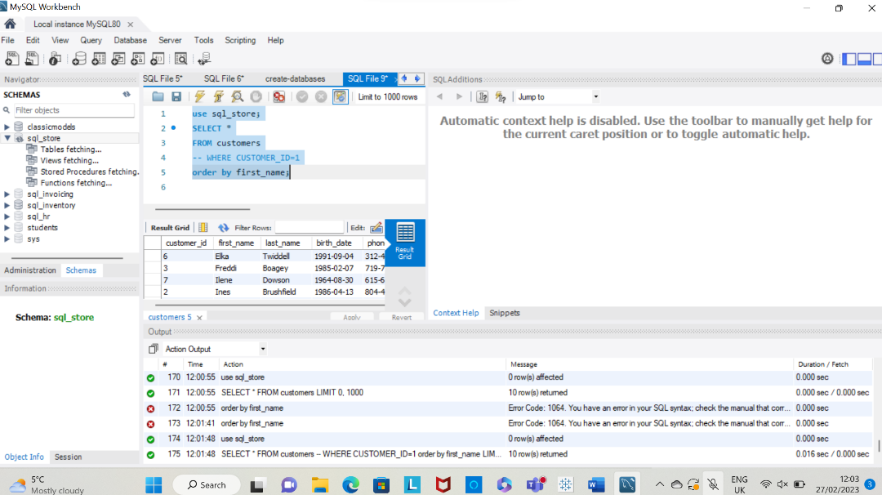

QUERY 2:

TASK 1:

Using the Query 2 you created change the points to reads times by 10 and plus 100. Record your results in your word document

Change the Query 2 code to create a discount factor so the table now shows a discount header and changing the (point + 10) *100​

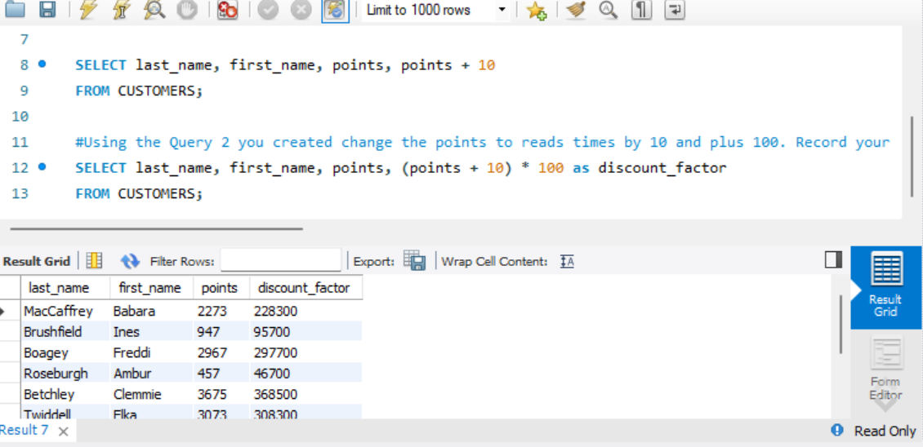

**TASK 2**

Write a SQL query to return all the products in our database in the result set. I want you to make three columns, name, unit price, and new column called new price which is based on this expression, (unit price * 1.1 ).​

So what you are doing is increasing the product price of each by 10%. ​

So with the query we want all the products the original price and the new  price.  ​

**TASK 3**

In this task create a new query to find all the customers with a birth date of > '1990-01-01'​

**TASK 4**

Select sql_inventory.​

Write a query to find out the name of the product with most amount in stock.​

**TASK 5**

Select sql_inventory.​

Write a query to find out the name of the most expensive product.​

**EER DIAGRAM**

The primary key for the above EER Diagram is order_id INT

Customer_id INT is the Foreign key for Orders and connects with Foreign key for customers.